TAGT Website Content Sheet
This is where you tell us what to change on the website. Find your page, find the number, type your new words. That's it.

Start here (1 minute)
- Scroll to your page. Each page has a picture with gold numbered circles on it.
- Find the same number in the table under the picture. The “What it says now” column is what the website says today.
- Want to change it? Type your new words in the last column. If it's fine, leave that box empty.
Photos: the purple striped boxes are photo spots. Put your photo in the TAGT Photos folder, then type the photo's file name in the last column of the photo table.

Good to know
- You can't break the website by typing here. Nothing changes on the live website until Dani reviews it.
- Please don't change the numbers.
- [Needs your words] means we don't have this yet. Please fill it in.
- Service times, menu words, and the footer only live in the “Every page” section. Change them there once and they change everywhere.

Every page (top menu, bottom footer, service times)
These parts show on every page of the website. The picture is the Home page, numbered only for the top menu, the service times, and the footer.
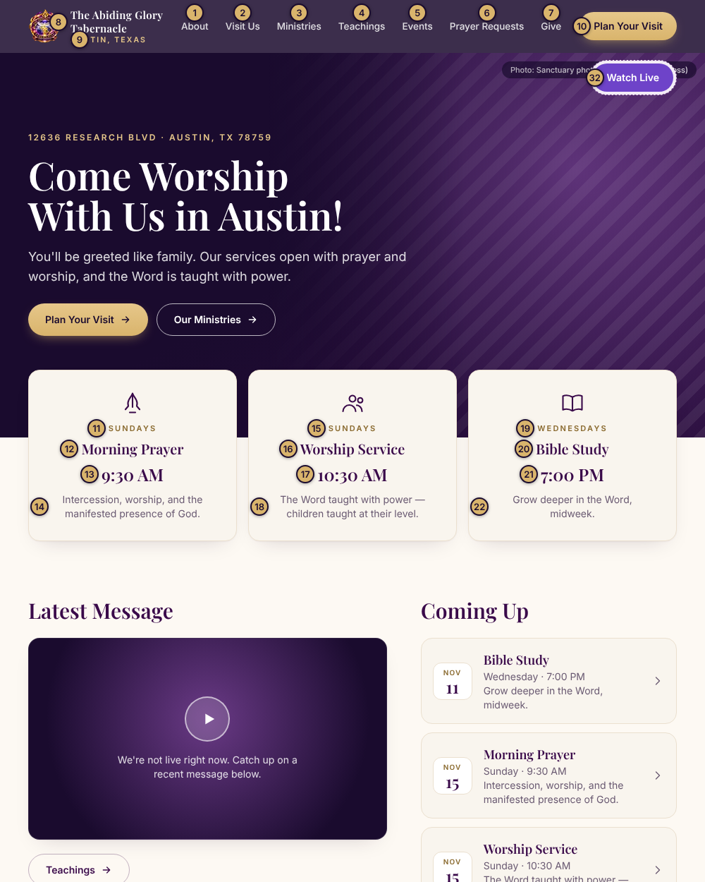
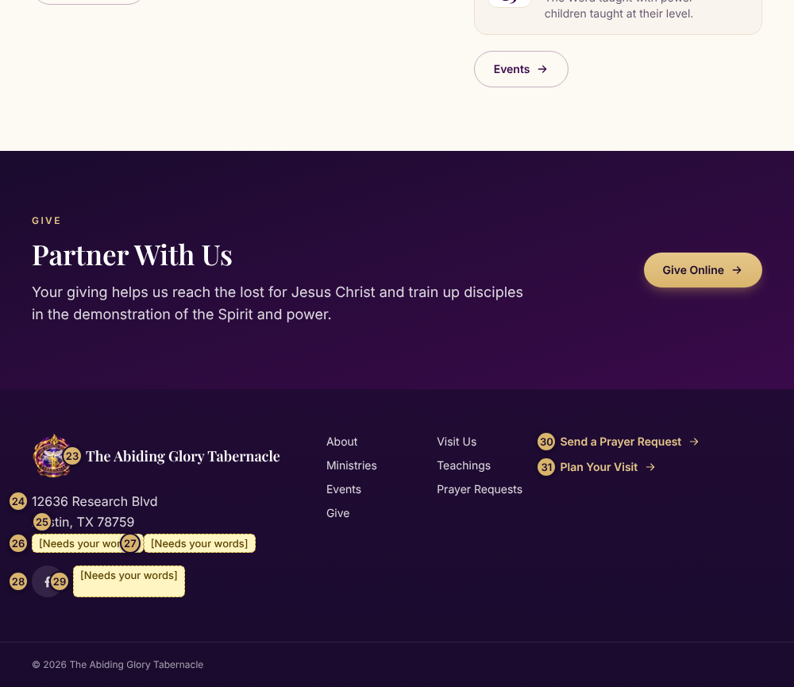

Words
# | Part of the page | What it says now | Your new words (leave blank to keep)
1 | Menu word 1 | About
2 | Menu word 2 | Visit Us
3 | Menu word 3 | Ministries
4 | Menu word 4 | Teachings
5 | Menu word 5 | Events
6 | Menu word 6 | Prayer Requests
7 | Menu word 7 | Give
8 | Church name (top left) | The Abiding Glory Tabernacle
9 | Small city line under the name | AUSTIN, TEXAS
10 | Gold button at the top right | Plan Your Visit
11 | Service 1: day | SUNDAYS
12 | Service 1: name | Morning Prayer
13 | Service 1: time | 9:30 AM
14 | Service 1: short line | Intercession, worship, and the manifested presence of God.
15 | Service 2: day | SUNDAYS
16 | Service 2: name | Worship Service
17 | Service 2: time | 10:30 AM
18 | Service 2: short line | The Word taught with power — children taught at their level.
19 | Service 3: day | WEDNESDAYS
20 | Service 3: name | Bible Study
21 | Service 3: time | 7:00 PM
22 | Service 3: short line | Grow deeper in the Word, midweek.
23 | Footer: church name | The Abiding Glory Tabernacle
24 | Footer: street address | 12636 Research Blvd
25 | Footer: city, state, zip | Austin, TX 78759
26 | Footer: church email | [Needs your words]
27 | Footer: church phone | [Needs your words]
28 | Footer: Facebook link | facebook.com/TheAbidingGloryTabernacle
29 | Footer: YouTube link | [Needs your words]
30 | Footer: link words 1 | Send a Prayer Request
31 | Footer: link words 2 | Plan Your Visit
32 | Top right button on the Teachings page | Watch Live

Home
The first page people see: a welcome, service times, the latest message, what's coming up, and giving.
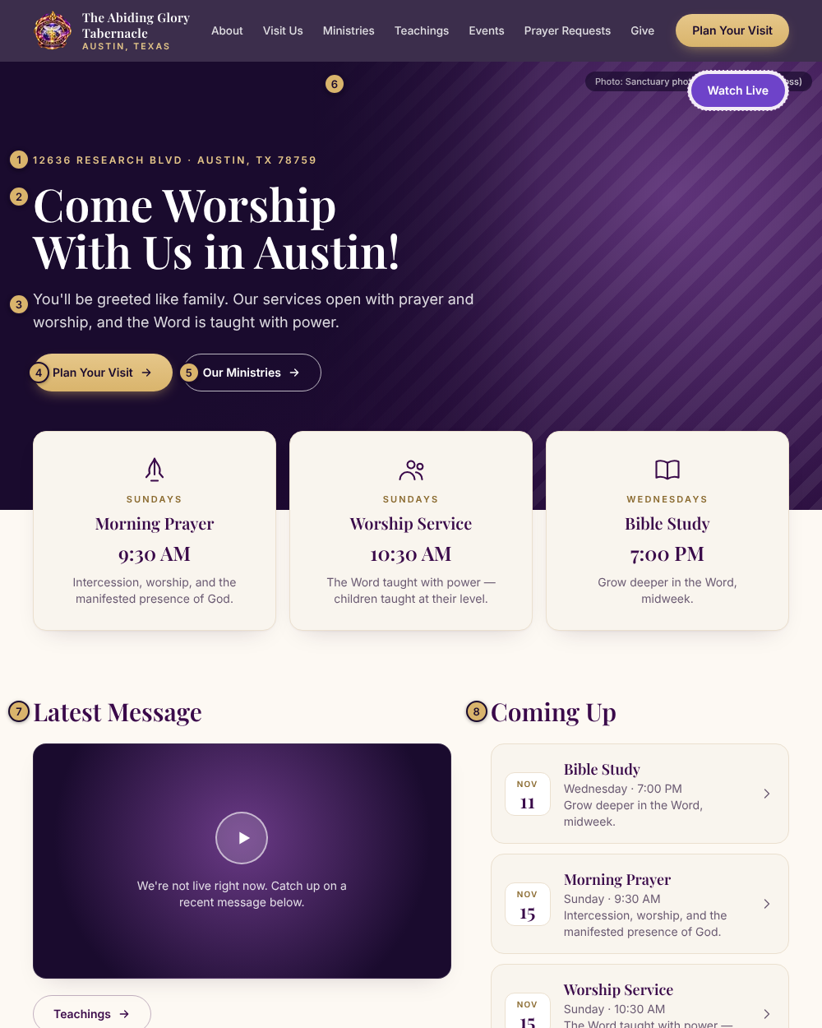
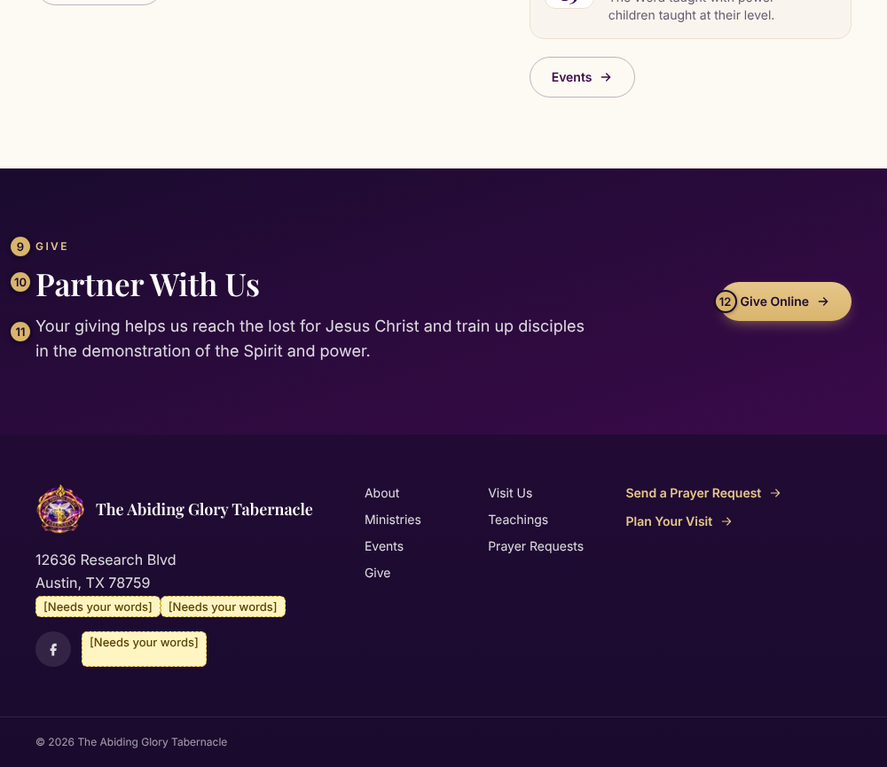

Words
# | Part of the page | What it says now | Your new words (leave blank to keep)
1 | Small address line above the headline | 12636 RESEARCH BLVD · AUSTIN, TX 78759
2 | Big headline | Come Worship With Us in Austin!
3 | Text under the headline | You'll be greeted like family. Our services open with prayer and worship, and the Word is taught with power.
4 | Gold button | Plan Your Visit
5 | Outline button | Our Ministries
7 | Heading above the latest video | Latest Message
8 | Heading above the events | Coming Up
9 | Small gold word above the giving heading | GIVE
10 | Giving heading | Partner With Us
11 | Giving message | Your giving helps us reach the lost for Jesus Christ and train up disciples in the demonstration of the Spirit and power.
12 | Giving button | Give Online

Photos
# | Photo spot | What is there now | Photo file name (type it here)
6 | Big picture at the top of the page | Sanctuary photo (the banners and cross)

About
Who we are and what we believe.
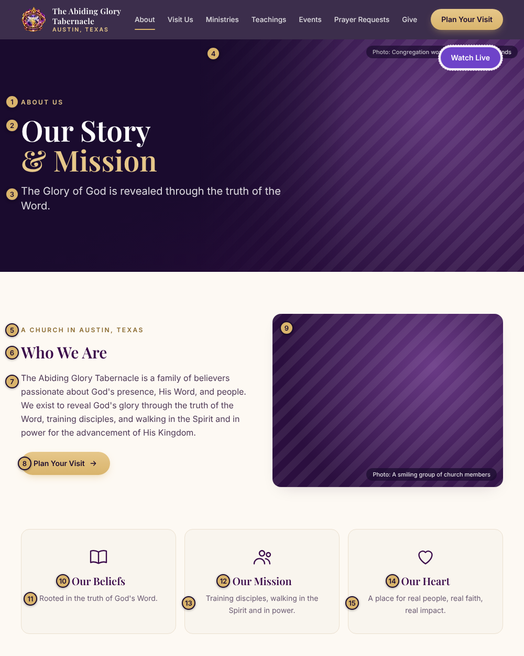
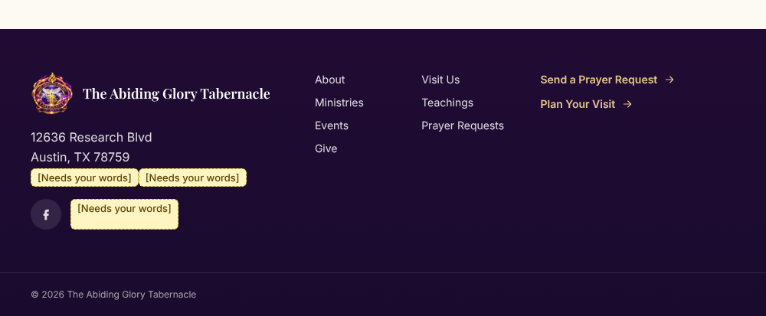

Words
# | Part of the page | What it says now | Your new words (leave blank to keep)
1 | Small gold word at the top | ABOUT US
2 | Big headline | Our Story & Mission
3 | Text under the headline | The Glory of God is revealed through the truth of the Word.
5 | Small gold words above “Who We Are” | A CHURCH IN AUSTIN, TEXAS
6 | Heading | Who We Are
7 | Paragraph | The Abiding Glory Tabernacle is a family of believers passionate about God's presence, His Word, and people. We exist to reveal God's glory through the truth of the Word, training disciples, and walking in the Spirit and in power for the advancement of His Kingdom.
8 | Button | Plan Your Visit
10 | Box title: Our Beliefs | Our Beliefs
11 | Box words: Our Beliefs | Rooted in the truth of God's Word.
12 | Box title: Our Mission | Our Mission
13 | Box words: Our Mission | Training disciples, walking in the Spirit and in power.
14 | Box title: Our Heart | Our Heart
15 | Box words: Our Heart | A place for real people, real faith, real impact.

Photos
# | Photo spot | What is there now | Photo file name (type it here)
4 | Big picture at the top of the page | Congregation worshiping with raised hands
9 | Photo next to “Who We Are” | A smiling group of church members

Visit Us
Everything a first-time guest needs: service times, directions, what to expect, and a form to tell us they're coming.
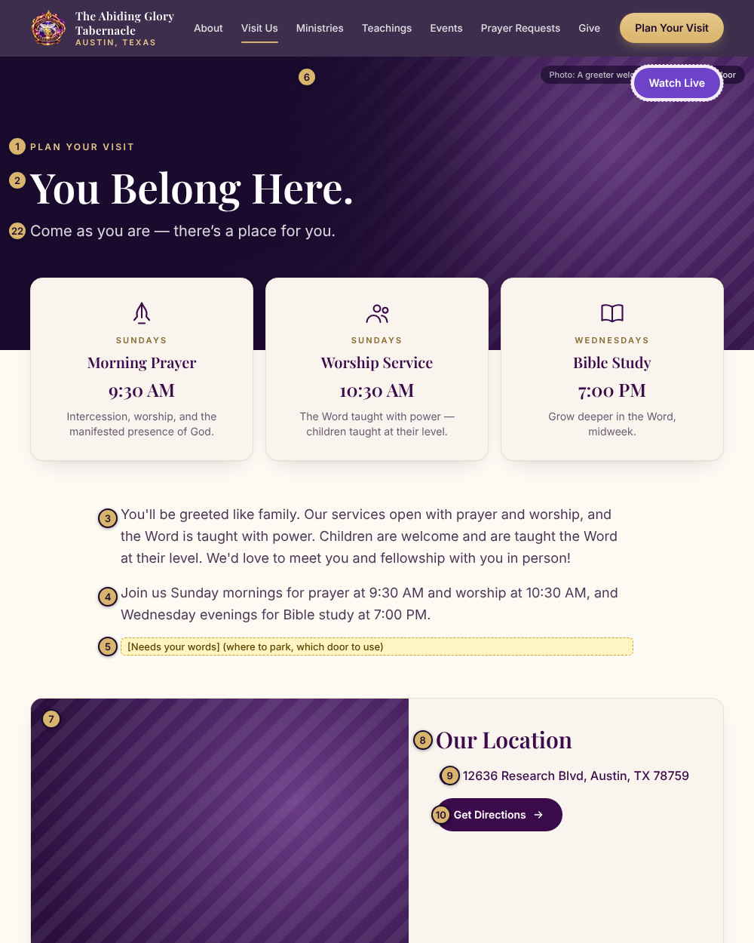
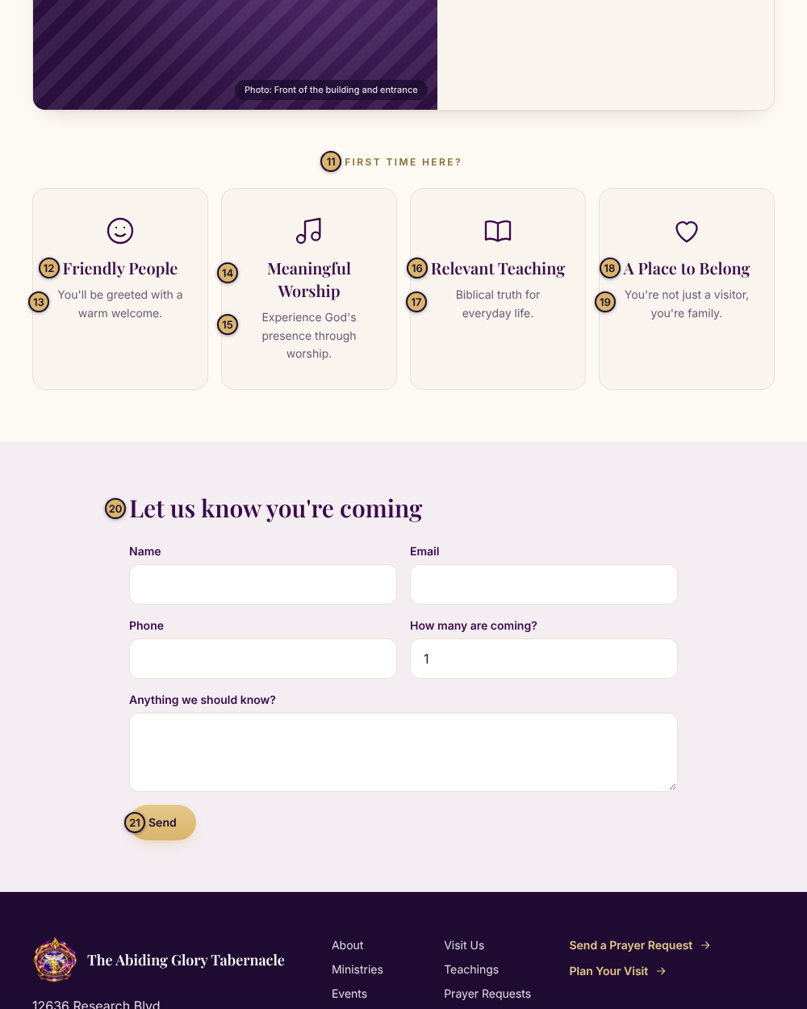
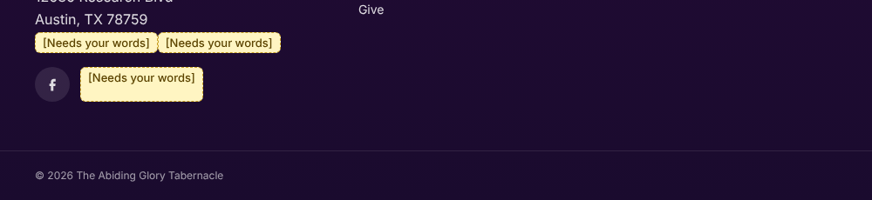

Words
# | Part of the page | What it says now | Your new words (leave blank to keep)
1 | Small gold word at the top | PLAN YOUR VISIT
2 | Big headline | You Belong Here.
3 | First paragraph | You'll be greeted like family. Our services open with prayer and worship, and the Word is taught with power. Children are welcome and are taught the Word at their level. We'd love to meet you and fellowship with you in person!
4 | Second paragraph | Join us Sunday mornings for prayer at 9:30 AM and worship at 10:30 AM, and Wednesday evenings for Bible study at 7:00 PM.
5 | Parking and entrance note | [Needs your words] (where to park, which door to use)
8 | Heading by the address | Our Location
9 | Address words | 12636 Research Blvd, Austin, TX 78759
10 | Button under the address | Get Directions
11 | Small gold words above the four boxes | FIRST TIME HERE?
12 | Box title: Friendly People | Friendly People
13 | Box words: Friendly People | You'll be greeted with a warm welcome.
14 | Box title: Meaningful Worship | Meaningful Worship
15 | Box words: Meaningful Worship | Experience God's presence through worship.
16 | Box title: Relevant Teaching | Relevant Teaching
17 | Box words: Relevant Teaching | Biblical truth for everyday life.
18 | Box title: A Place to Belong | A Place to Belong
19 | Box words: A Place to Belong | You're not just a visitor, you're family.
20 | Heading above the “I’m coming” form | Let us know you're coming
21 | Form button | Send
22 | Line under the headline | Come as you are — there’s a place for you.

Photos
# | Photo spot | What is there now | Photo file name (type it here)
6 | Picture at the top of the page | A greeter welcoming a guest at the door
7 | Photo of the building | Front of the building and entrance

Ministries
Our ministries and when they meet.
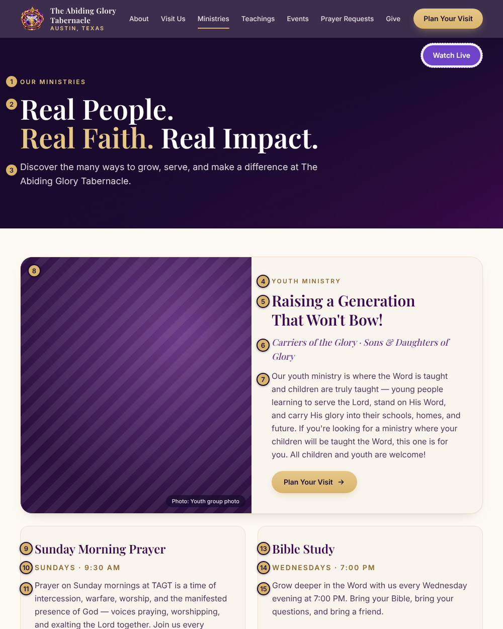
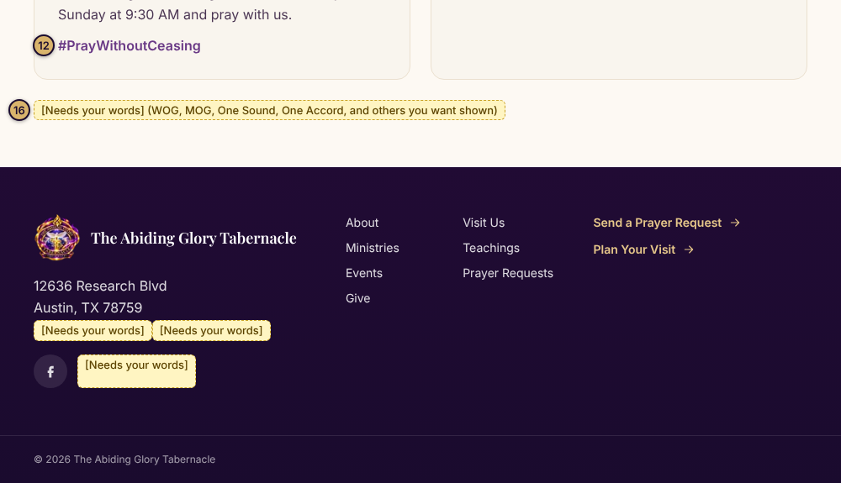

Words
# | Part of the page | What it says now | Your new words (leave blank to keep)
1 | Small gold word at the top | OUR MINISTRIES
2 | Big headline | Real People. Real Faith. Real Impact.
3 | Text under the headline | Discover the many ways to grow, serve, and make a difference at The Abiding Glory Tabernacle.
4 | Small gold label on the big box | YOUTH MINISTRY
5 | Big box headline | Raising a Generation That Won't Bow!
6 | Line under the headline | Carriers of the Glory · Sons & Daughters of Glory
7 | Big box paragraph | Our youth ministry is where the Word is taught and children are truly taught — young people learning to serve the Lord, stand on His Word, and carry His glory into their schools, homes, and future. If you're looking for a ministry where your children will be taught the Word, this one is for you. All children and youth are welcome!
9 | Box title (left) | Sunday Morning Prayer
10 | Day and time (left) | Sundays · 9:30 AM
11 | Box paragraph (left) | Prayer on Sunday mornings at TAGT is a time of intercession, warfare, worship, and the manifested presence of God — voices praying, worshipping, and exalting the Lord together. Join us every Sunday at 9:30 AM and pray with us.
12 | Hashtag (left) | #PrayWithoutCeasing
13 | Box title (right) | Bible Study
14 | Day and time (right) | Wednesdays · 7:00 PM
15 | Box paragraph (right) | Grow deeper in the Word with us every Wednesday evening at 7:00 PM. Bring your Bible, bring your questions, and bring a friend.
16 | More ministry boxes to add | [Needs your words] (WOG, MOG, One Sound, One Accord, and others you want shown)

Photos
# | Photo spot | What is there now | Photo file name (type it here)
8 | Youth ministry photo | Youth group photo

Teachings
Where people watch the live service and past messages.
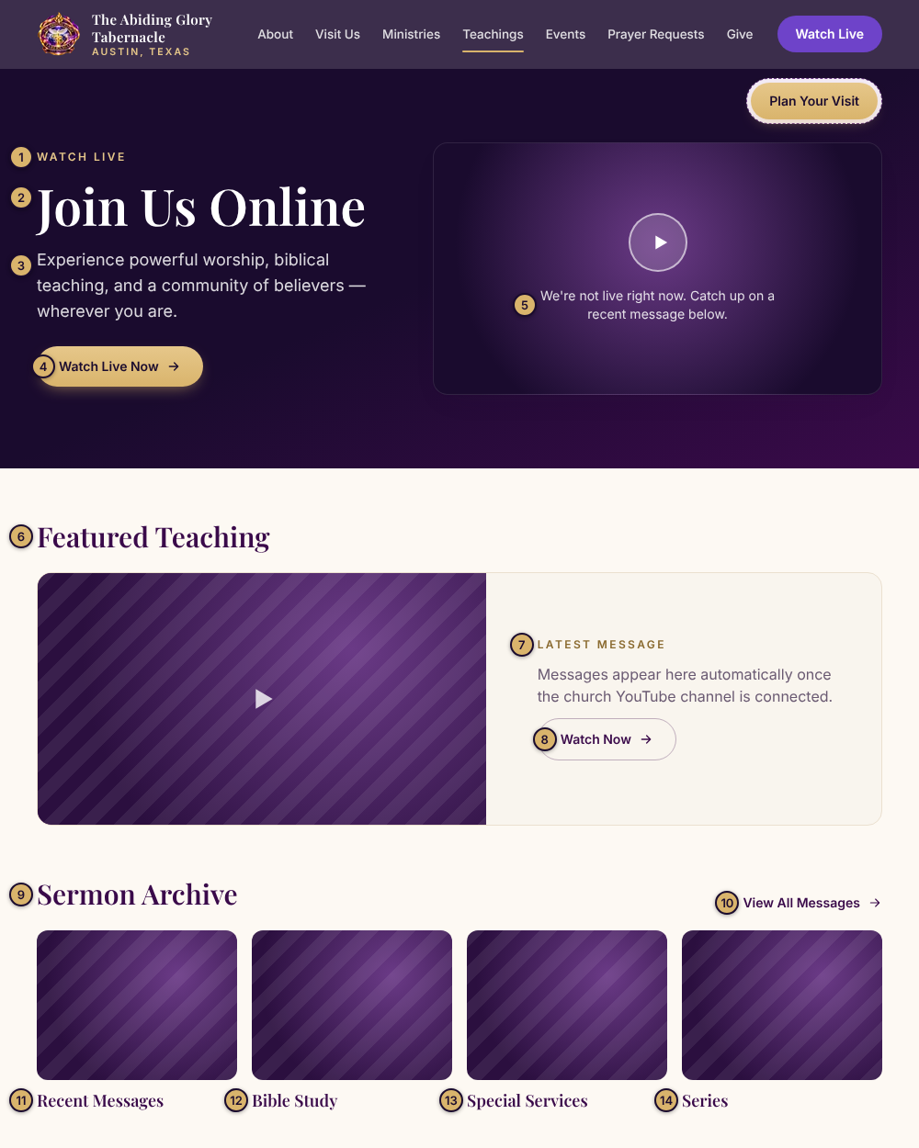
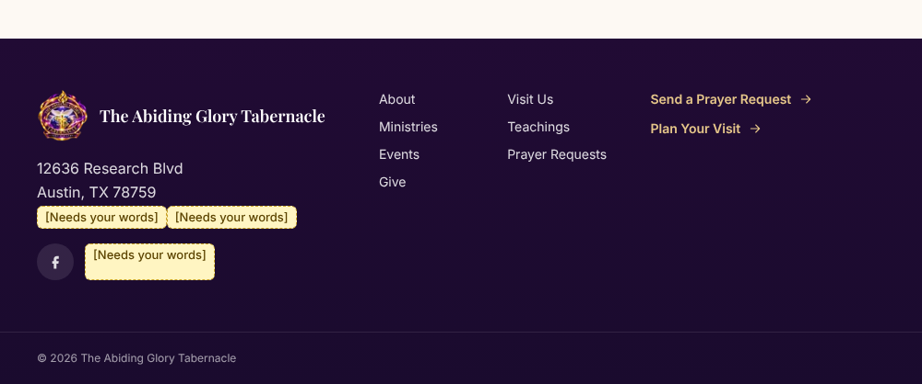

Words
# | Part of the page | What it says now | Your new words (leave blank to keep)
1 | Small gold word at the top | WATCH LIVE
2 | Big headline | Join Us Online
3 | Text under the headline | Experience powerful worship, biblical teaching, and a community of believers — wherever you are.
4 | Gold button | Watch Live Now
5 | Message shown when we are NOT live | We're not live right now. Catch up on a recent message below.
6 | Heading | Featured Teaching
7 | Small gold label | LATEST MESSAGE
8 | Button | Watch Now
9 | Heading for past messages | Sermon Archive
10 | Link words | View All Messages
11 | Group name 1 | Recent Messages
12 | Group name 2 | Bible Study
13 | Group name 3 | Special Services
14 | Group name 4 | Series

Events
The church calendar and what's coming up.
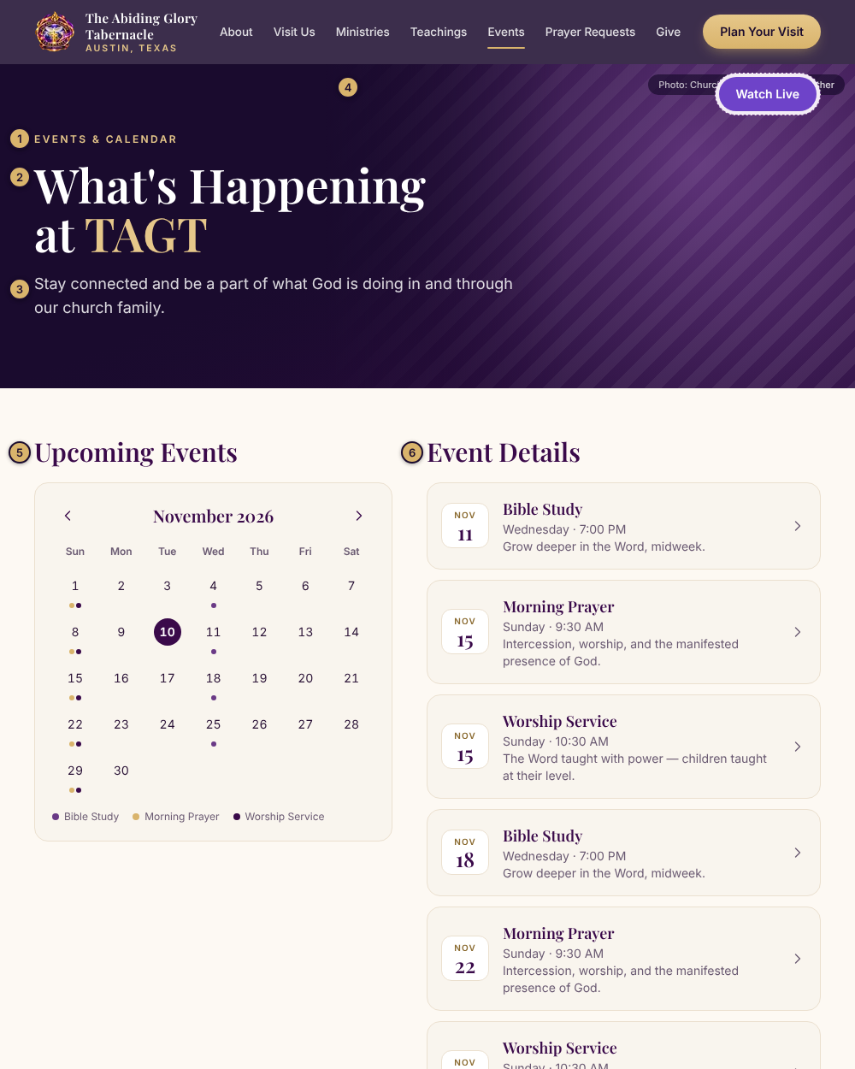
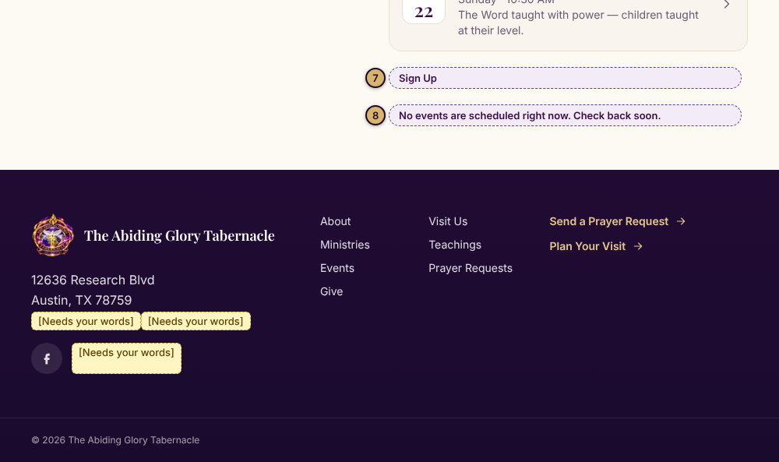

Words
# | Part of the page | What it says now | Your new words (leave blank to keep)
1 | Small gold word at the top | EVENTS & CALENDAR
2 | Big headline | What's Happening at TAGT
3 | Text under the headline | Stay connected and be a part of what God is doing in and through our church family.
5 | Heading above the calendar | Upcoming Events
6 | Heading above the list | Event Details
7 | Sign-up button on events that need sign-ups | Sign Up
8 | Message when no events are scheduled | No events are scheduled right now. Check back soon.

Photos
# | Photo spot | What is there now | Photo file name (type it here)
4 | Big picture at the top of the page | Church family laughing together

Prayer Requests
Where people send a prayer request and choose who can see it.
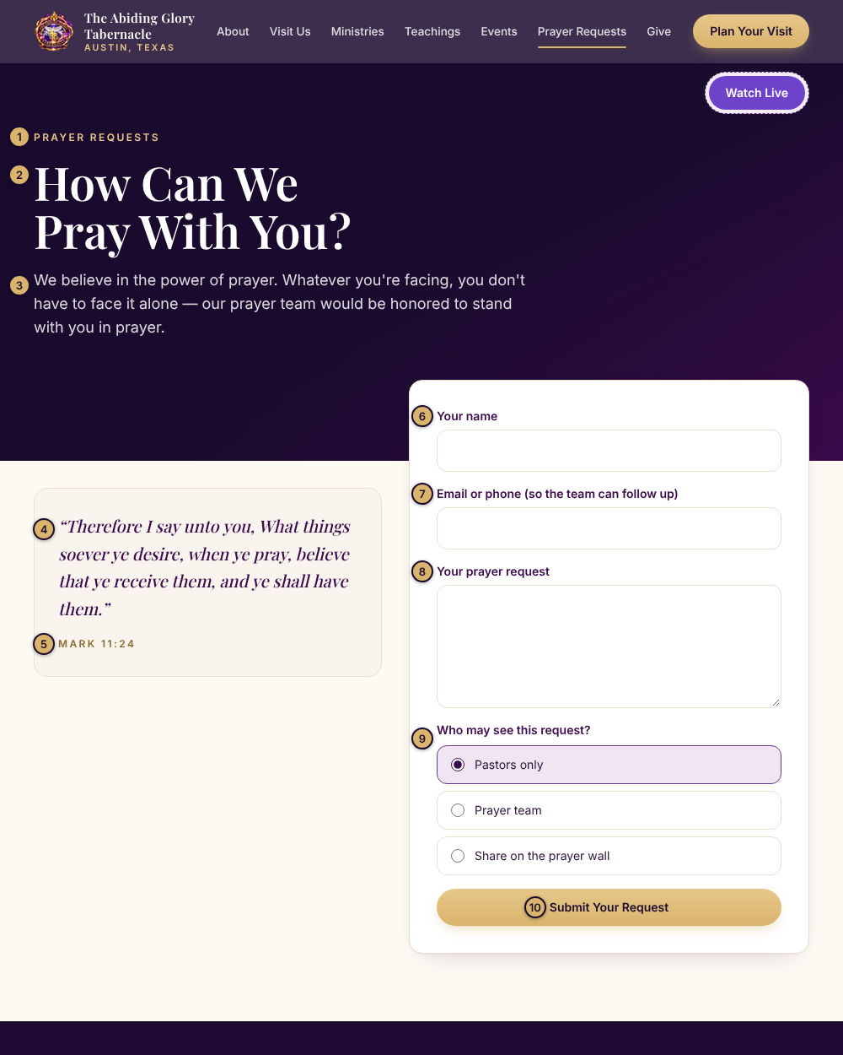
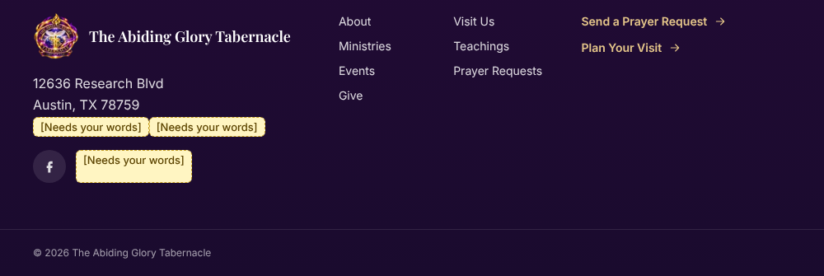

Words
# | Part of the page | What it says now | Your new words (leave blank to keep)
1 | Small gold word at the top | PRAYER REQUESTS
2 | Headline | How Can We Pray With You?
3 | Paragraph | We believe in the power of prayer. Whatever you're facing, you don't have to face it alone — our prayer team would be honored to stand with you in prayer.
4 | Scripture | “Therefore I say unto you, What things soever ye desire, when ye pray, believe that ye receive them, and ye shall have them.”
5 | Scripture reference | MARK 11:24
6 | Form: name box label | Your name
7 | Form: email or phone box label | Email or phone (so the team can follow up)
8 | Form: request box label | Your prayer request
9 | Question about who can see it | Who may see this request? ○ Pastors only ○ Prayer team ○ Share on the prayer wall
10 | Form button | Submit Your Request

Give
Ways to give, and how to reach the church.
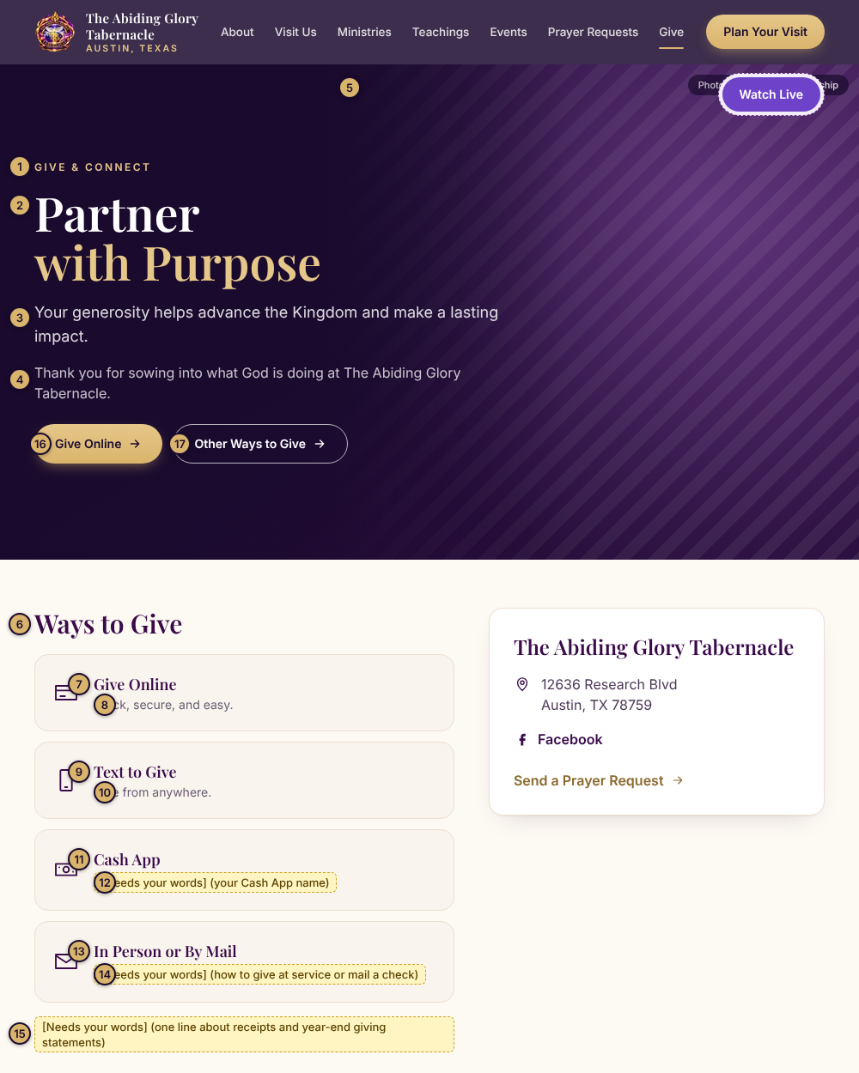
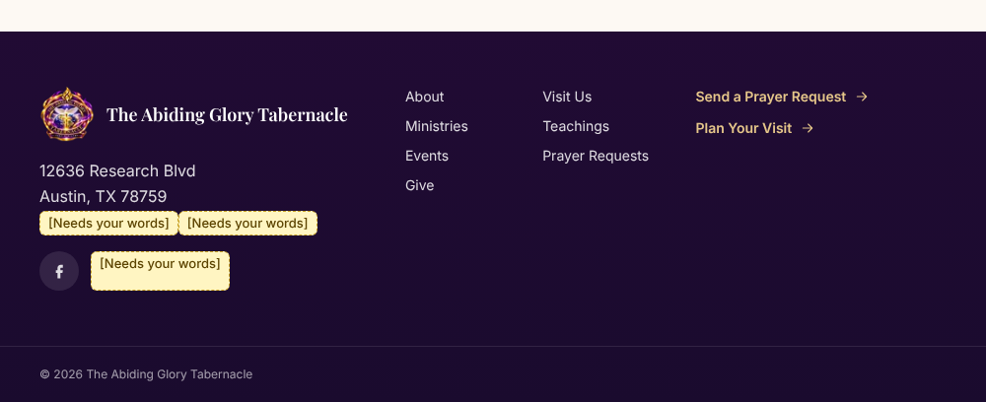

Words
# | Part of the page | What it says now | Your new words (leave blank to keep)
1 | Small gold word at the top | GIVE & CONNECT
2 | Big headline | Partner with Purpose
3 | First paragraph | Your generosity helps advance the Kingdom and make a lasting impact.
4 | Second paragraph | Thank you for sowing into what God is doing at The Abiding Glory Tabernacle.
6 | Heading above the ways to give | Ways to Give
7 | Box title: Give Online | Give Online
8 | Box words: Give Online | Quick, secure, and easy.
9 | Box title: Text to Give | Text to Give
10 | Box words: Text to Give | Give from anywhere.
11 | Box title: Cash App | Cash App
12 | Box words: Cash App | [Needs your words] (your Cash App name)
13 | Box title: In Person or By Mail | In Person or By Mail
14 | Box words: In Person or By Mail | [Needs your words] (how to give at service or mail a check)
15 | Line about giving receipts | [Needs your words] (one line about receipts and year-end giving statements)
16 | Gold button in the top picture | Give Online
17 | Outline button in the top picture | Other Ways to Give

Photos
# | Photo spot | What is there now | Photo file name (type it here)
5 | Picture at the top of the page | Hands raised in worship

For Dani and Claude Code only (team can skip this)
How an import works:
- Export this doc as Markdown to /content/site-copy.md. Photos go in /content/images/.
- A row is identified by page section plus number (for example 3-visit-us #5).
- Only rows where “Your new words” or “Photo file name” is not empty get imported. Empty means keep what's live.
- Write photo alt text from the image itself.
- Do not renumber. New spots get the next unused number in their section.
- Run the import script, scripts/import-content (being built next). Report every change, and never publish without Dani's go-ahead.
Section keys: 0-every-page, 1-home, 2-about, 3-visit-us, 4-ministries, 5-teachings, 6-events, 7-prayer-requests, 8-give

